General Guidance:

1. Each member in one group will perform INDEPENDENT data analysis, which is described in the project description. But you are encouraged to discuss your codes/methods/models, and outputs with your teammates.
2. Each member in one group will write an INDIVIDUAL weekly project reports.
3. All members in one group will present as a GROUP (not individually) for first three weeks.

____________________________

Here are detailed instruction for Project-Report #1, 5PM today:

Use the provided Data: “MorphII_BIF_s7-37_g0.1_max_partial.csv”.

More details: <http://libres.uncg.edu/ir/uncw/f/wangy2018-1.pdf>

1) Perform both numerical summaries and graphical summaries to dataset: variables include age, gender, race from the first column. All rest columns are Bio-Inspired Feature (BIF). Find the overall summaries for all the rest of BIF features.

During today’s tutorial, Dr. Chen introduced many R codes to produce graphs or statistics. You can check R Labs for chap2 and Chap3. **Your graphs should be meaningful, colorful, and with all main titles, x-label and y-labels.**

2) For all numerical summaries and graphical summaries, students are required to draw corresponding conclusions in your report.

3) Submit a separated LastName_Project1.r with all R codes (or code from other programming language) into Google folder: 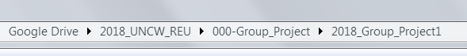. Note: All R codes should be reproducible by Dr. Chen in order to produce all reported tables, and graphs. (Never copy from your ***command*** window!!!).

5) Please list clearly your Name/Date on the first page, then list the Project #.